Cost & Performance Analysis in PySpark

1. DataFrame Creation
DataFrames improve performance using optimized query execution and reduce resource consumption.

What it does:
- Uses structured data (schema-based) instead of raw RDDs( Resilient Distributed Dataset )

Performance Benefit:
- Spark uses Catalyst Optimizer → better execution plans
- Faster than RDD operations

Cost Benefit:
- Efficient execution → less CPU usage → lower compute cost

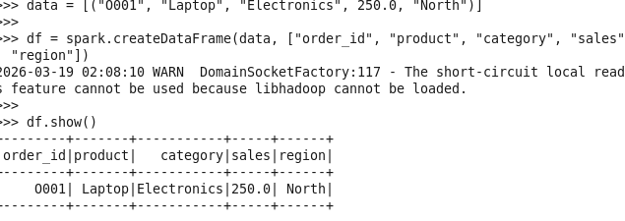

2 .Parquet Concept
Parquet reduces I/O and storage cost while improving query speed using columnar storage.

What it does:
- Stores data in columnar format

Performance Benefit:
- Reads only required columns
- Supports compression

Cost Benefit:
- Less data read → less I/O → faster jobs
- Smaller storage size → lower storage cost
Example:
Instead of reading 10 columns → Spark reads only 2 needed columns

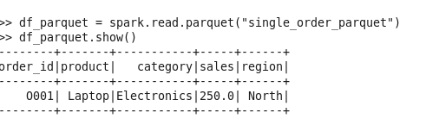

3. Partitioning
Partitioning enables parallel processing, improving speed and resource utilization.

What it does:
- Splits data into chunks for parallel processing

Performance Benefit:
- More partitions → better parallelism → faster execution
- Balanced partitions → avoids idle executors

Cost Benefit:
- Efficient CPU usage → no wasted resources
- Avoids long-running tasks → reduced cluster time
Bad case:
- 1 partition → only 1 core used
Good case:
- 10 partitions → 10 cores used ✅

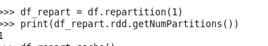

4. Caching
Caching avoids recomputation and significantly improves performance for repeated operations.

What it does:
- Stores data in memory for reuse

Performance Benefit:
- Avoids recomputation of same data
- Faster repeated queries

Cost Benefit:
- Reduces repeated computation → saves CPU time
- Less job execution time → lower cost
Example:
Without cache:
df → join → groupBy → run again → recompute
With cache:
df cached → reused → no recomputation

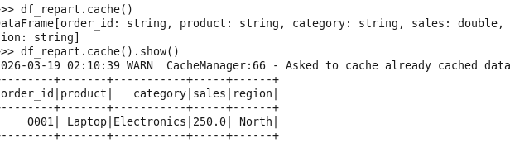

5. Aggregation
Aggregation reduces data volume, improving processing efficiency and lowering compute cost.

What it does:Summarizes data using groupBy, sum, etc.

Performance Benefit:
- Reduces dataset size after aggregation
- Optimized using Spark execution engine

Cost Benefit:
- Less data processed downstream → lower memory & CPU usage

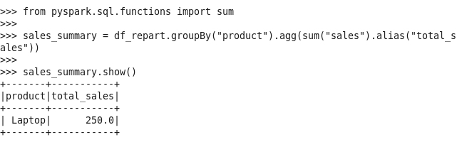

6. Ranking

Assigning a unique rank to each distinct value.

Use of ranking:
- Uses window functions to find top N results

Performance Benefit:
- Efficient sorting using Spark engine

Cost Benefit:
- Avoids manual sorting logic → optimized execution
- Instead of writing more code for fetching particular total sales like 3 highest total sales based on rank we can easily get the data
.

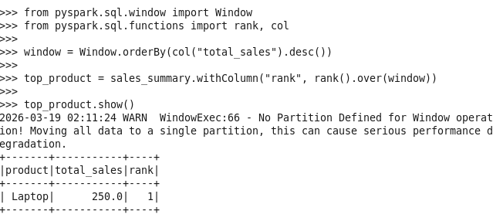

7. Performance Tuning

What it does:
- Adjusts Spark configurations

Performance Benefit:
- spark.sql.shuffle.partitions → controls parallelism
- AQE → automatically optimizes queries
- Better memory & CPU utilization

Cost Benefit:
- Avoids overuse of resources
- Faster job completion → less cluster usage cost

